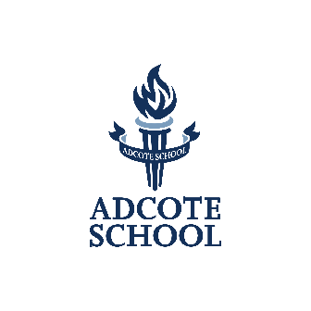
SCHOLARSHIP APPLICATION FORM
Please read the Scholarship notes before completing the application form

Candidates Full Name:
Age:
Date of Birth:
Current Year Group:

Parent Name:
Address:
Contact Number:
Email Address:

Please tick the box for the scholarship that you wish to apply for:

I would like to enter my daughter for an:

Academic Scholarship

Music Scholarship

Art Scholarship

Gymnastics Scholarship

All-Rounder Scholarship

Sports Scholarship

Performing Arts Scholarship

(NB: For candidates to be eligible for an all-rounder scholarship, candidates must enter for the academic scholarship and at least one of the other scholarships listed above)

We wish to apply for a Scholarship to Adcote School for entry in September 2024
Parent Full Name:
Signed:
Date:

Please return your application form to: Head of Admissions, Kim Davies
Adcote School, Little Ness, Shrewsbury SY4 2JY

Scholarship application deadline: Friday 13th October 2023
Scholarship exam: Friday 10th November 2023

